 

**Placement Empowerment Program**

***Cloud Computing and DevOps Centre***

Set Up a Local Git Repository: Initialize a Git repository locally and version control your static website

Name: Shakthi Lakshmanan V Department: CSE



**Introduction**

Version control helps you track changes in your project, making it easy to update, collaborate, and undo mistakes. Git is a widely used tool for version control.

In this guide, we will set up Git to manage changes in a static website. This will help keep your project organized and allow you to track updates easily.

**Steps to Follow**

1. **Install Git** – Ensure Git is installed on your computer.
2. **Create a Local Repository** – Initialize Git in your project folder.
3. **Track Changes** – Add and save files using Git.
4. **Check Repository Status** – Use Git commands to monitor changes.

**Objectives**

* Understand the basics of version control.
* Set up a Git repository for your project.
* Track and save changes effectively.
* Maintain an organized workflow.
* Prepare for collaboration.

**Why Use Git?**

* **Track Changes** – Monitor updates in your project.
* **Undo Mistakes** – Revert to previous versions when needed.
* **Collaborate Easily** – Work with others efficiently.

**Step-by-Step Overview**

Step 1:

Search for "Git" in Chrome, download it, and click the "Downloads" option on the website.

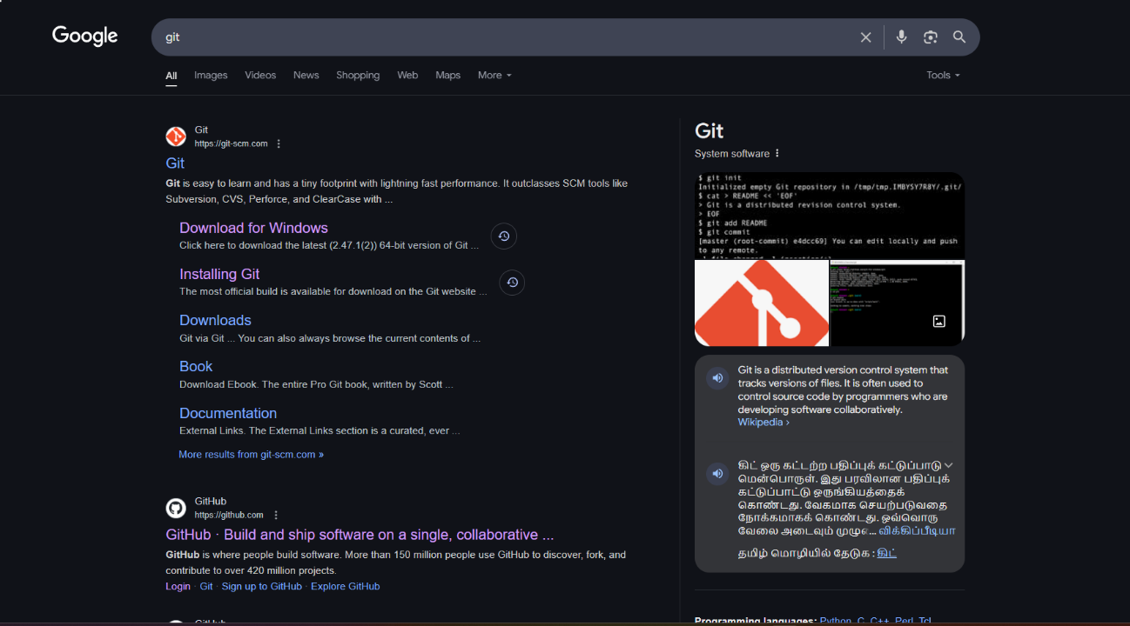



Step 2

Click the **Windows** option on the download page and follow the installation wizard.

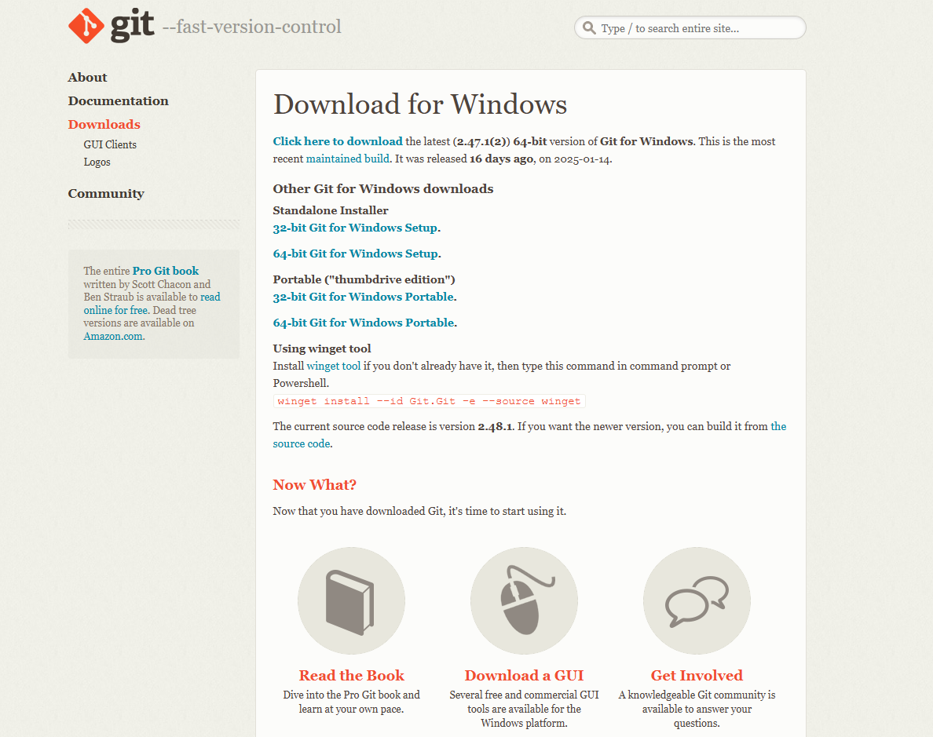

Step 3

In your Desktop Create a folder named Sample for your static website

Inside that folder, create a simple HTML file named Summa.html . You can write some basic HTML

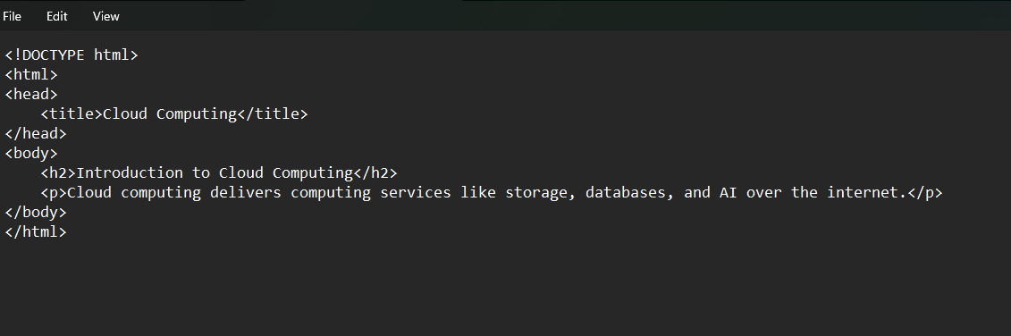

Step 4

Open the Command prompt and set the path to the folder named website we created

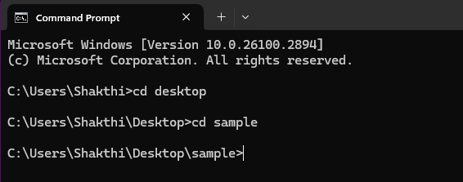

Step 5

Now, initialize Git by typing this command:

**git init**

This command will create a .git folder inside your project folder, which tells Git to start tracking your files.



Step 6

Next, we need to tell Git to start tracking your website files.

To tell Git which files to track, use the git add command. If you want to track all the files in your folder, type

**git add .**

This command adds all the files to Git’s tracking system.



Step 7

Set Up Your Name and Email Globally Git doesn’t know who is making the commit because you haven’t configured your name and email yet. Git uses this information to track who made the changes.



Step 8

Now, we need to save these changes in Git. When you "commit" changes, Git takes a snapshot of your files.

Type the following command to commit your changes:

**git commit -m "Initial commit of my static website"**

The -m flag allows you to add a message about your changes. In this case, we’re saying this is the "initial commit," meaning the first time we’re saving our work.

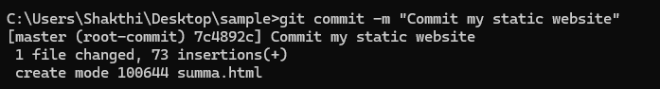

Step 9

**Create a New Repository**:

Once you're logged in, click the green **"New"** button on the top- right of your GitHub homepage to create a new repository.

Give your repository a name, for example, my-website.

Leave the other settings as default, and click **"Create repository"**.

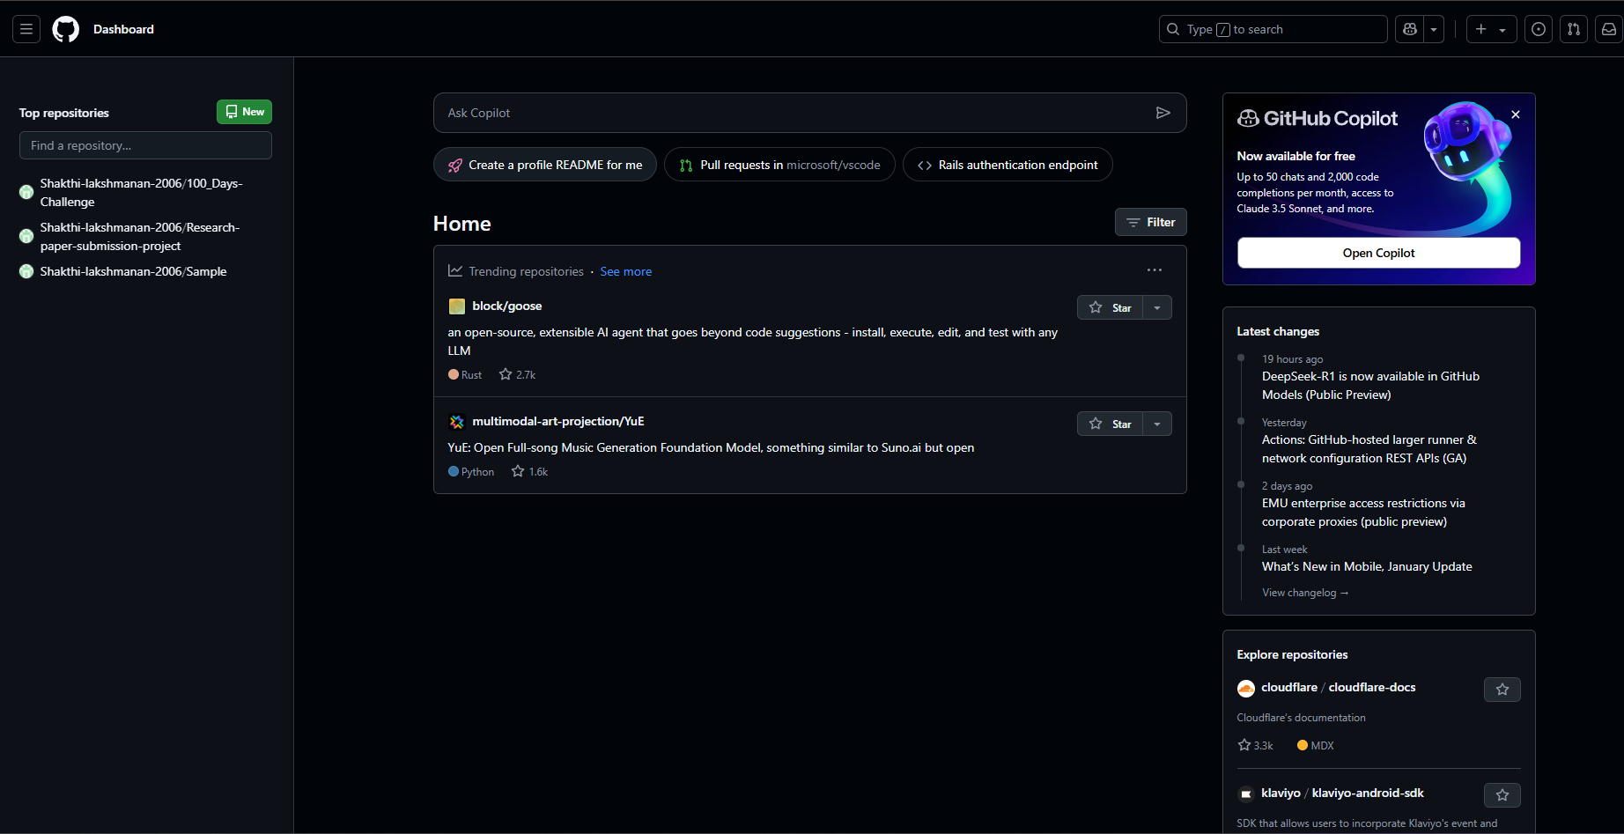

Step 10

**Add the Remote Repository URL to Your Local Repository**:

Go back to your Command Line and type the following:

**git remote add origin https://github.com/yourusername/my-website.git**

Replace yourusername with your GitHub username and my-website

with the name of your GitHub repository.



Step 11

The **git branch -M** main command is used to **rename the current branch** to main. Here's what it does:

**-M**: This flag forces the renaming, even if a branch named main already exists. It will overwrite the existing main branch.

**main**: This is the new name for the current branch.



Step 12

The command git **push -u origin main** is used to **push your local main branch to the remote repository (origin)** and set it as the upstream branch

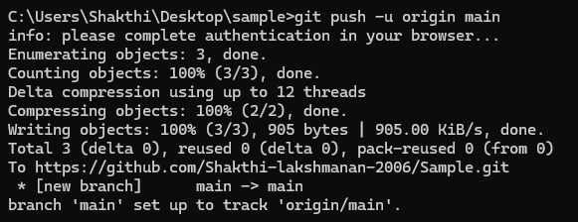

Step 13

Verify Your Files on GitHub

Go to your GitHub Repository:

Open your web browser and navigate to your GitHub repository (e.g., https://github.com/yourusername/my-website).

You should see your website files there!

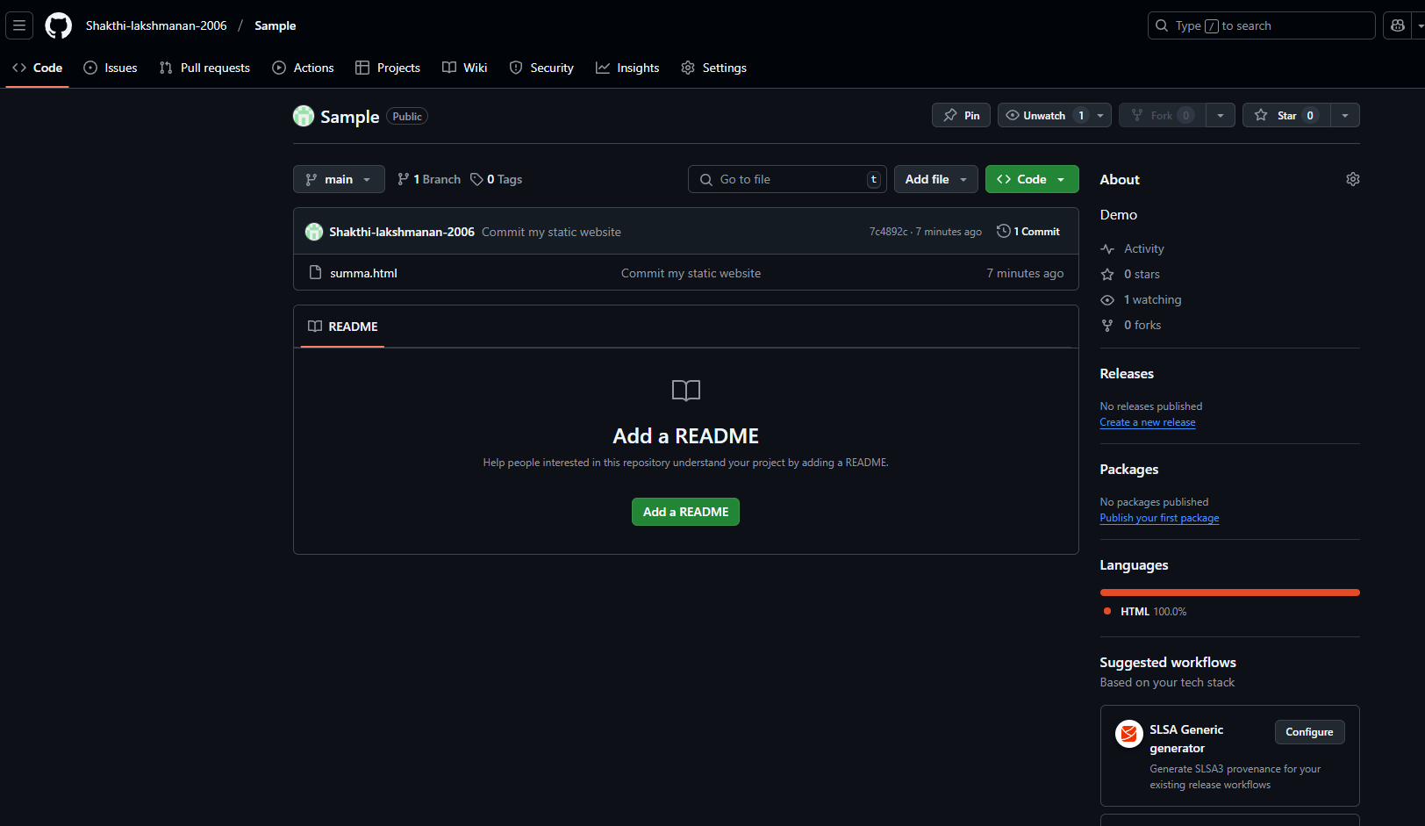

**Expected Outcome**

By completing this PoC of setting up a local Git repository, you will:

1. Successfully initialize a Git repository in your local static website folder.

2. Track changes made to your website files (HTML, CSS, etc.) using Git version control.

3. Understand the basic Git commands (git init, git add, git commit) for version control.

4. Commit your changes locally with a descriptive commit message.

5. Gain hands-on experience with Git and how it helps manage and track website file changes.